Version 0.2

What the hell goes on in STYX monitor land anyway?

Wireless rack stacks on top of ISO split with the G2 inputs of the split facing your side. Wedge rack (Grey cable) and side fill rack (Black cable) get patched via the G1 connectors that are loomed to proper length.

JY wedge is amp 1. Sub is amp 4. Amp 2 is not used and amp 3 is for FOH’s centerfills.

Downstage loom is a G1 and a EP4 along with a G1 to female XLR. Tommy Voc is 1, JY is 3, Ricky is 2.
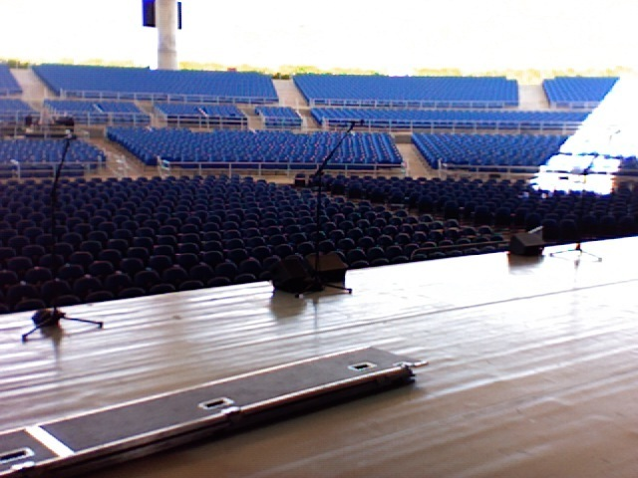

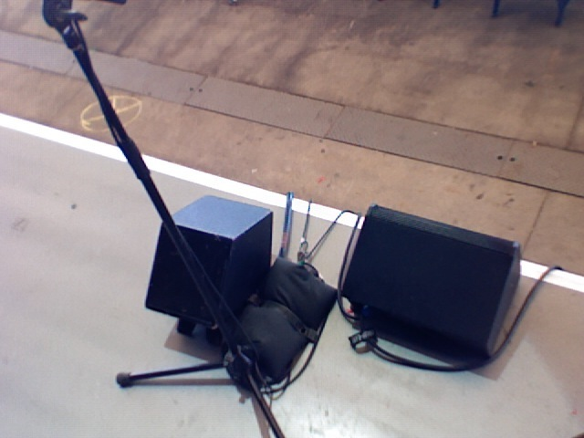FOH is on the ISO and monitors is DIRECT. Scene 001 is the only scene. If you put the DCA’s at 0 then you are at a good point. I usually use this during the show to get back to the start of most songs. JY gtr fader is pulled back and so is RP2. That is normal. JY fader comes up for twin guitar leads and RP2 fader comes up to about +4 for talking before Fooling Yourself when he and Tommy talk.

They get two Hubbell lines (one to JJ and one with a quad on it for Greg). Ross gets his power via the downstage loom that has the sidefill cable, audience mic cable.

Speaking of Audience mics, they are a direct patch into ADST4 of the console.

There is the one main loom that goes to the back of the drum riser. The Keyboard tech meets that loom with one of his. There is also an extra 50 foot G2 to extend into the guitar world wireless rack. It is the green G2 split input.

General vibe is listen to TS mix. Most things are post fade for him and others get the benefit of fader moves for him for certain inputs. Hats are key to these guys paying attention to intros if they space out (of course.)

Todd shouldn’t actually need anything all night nor will JY except for Key2 in his wedge for snowblind and vocoder for one with everything. JY will need Key2 to -3.6 for the first verse of Lorelei only.. Gowan needs guitars when he steps away from riser. TS guitar is easier to pitch to for Gowan.

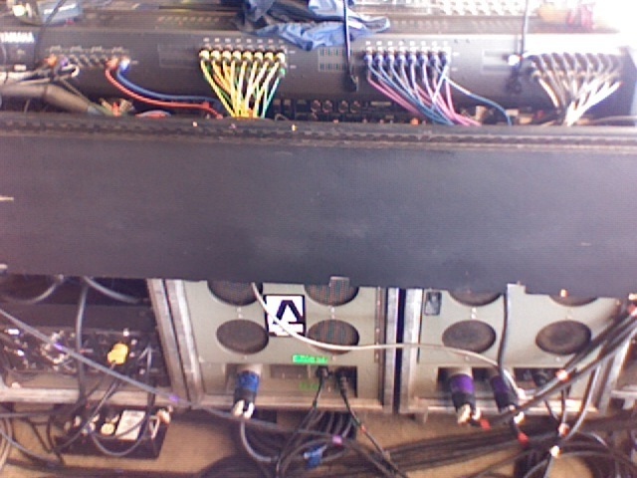
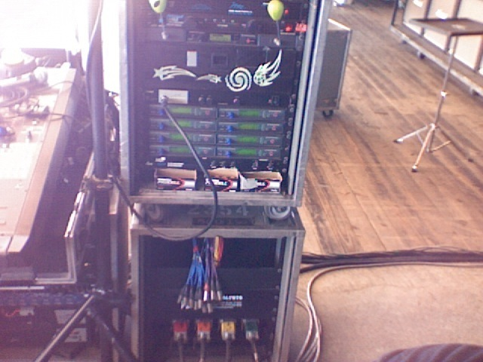
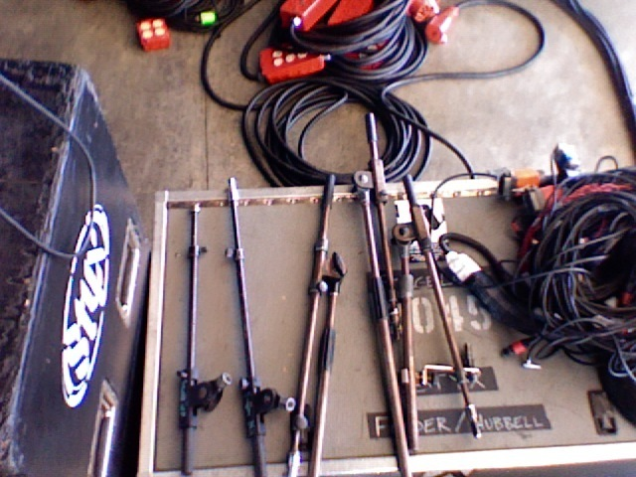
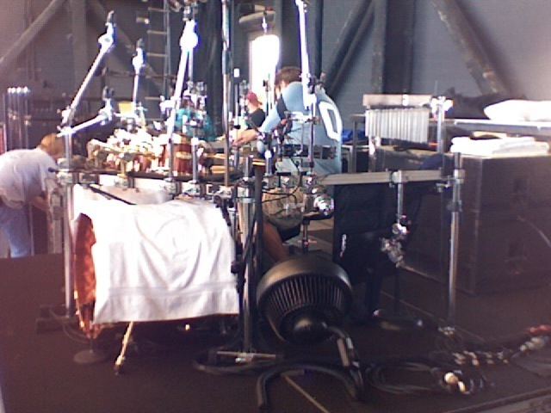
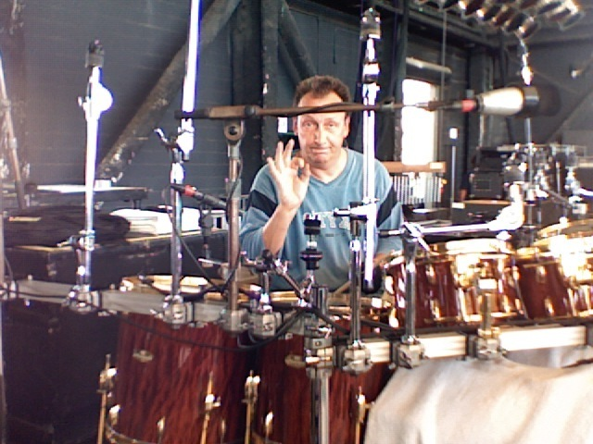
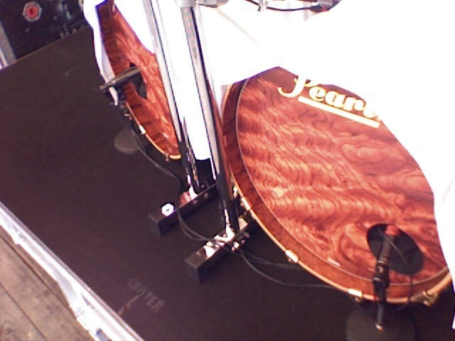
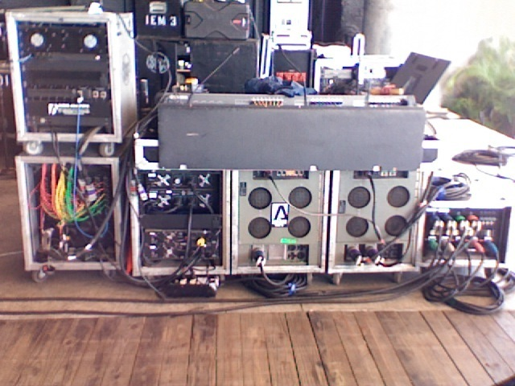
Wedge Amp Rack
2222
Side Fills
2708
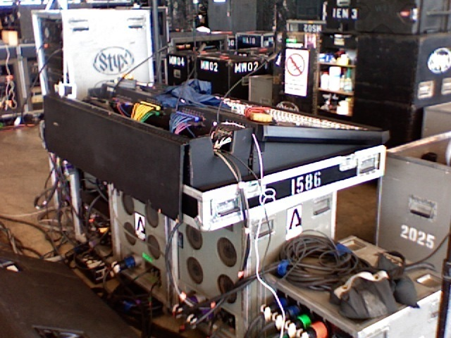
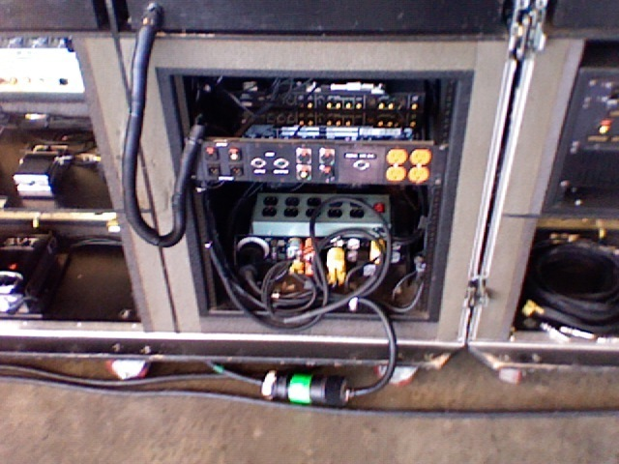

The Band

TS – Tommy Shaw – SL guitar player

LG – Lawrence Gowan – Keyboard player

RP – Ricky Phillips – Bass player – also guitar pod

Todd – Todd Sucherman – Drums

JY – James Young – Center guitar player

CP – Chuck Panozzo – Original bass player

Other Mix Outputs

JY Wedge – single 8” wedge at base of JY’s mic stand
Greg – Greg Mandelke – guitar tech for JY and RP
Sub – 2X18” subwoofer behind Todd
120X – dBx 120x Subharmonic generator

Mix 1/2 - Tommy FX L/R
Mix 3 – LG FX
Mix 4 – RP FX
Mix 5 – Todd Drum FX
Mix 6 –
Mix 7/8 – Sidefills SL/SR
IEM Round-up

Tommy – 3 packs | Ricky – 1 pack
Greg – 1 pack used | JY – 2 packs on guitar straps
Chuck – 1 pack on bass strap | Todd (spare that drum tech uses)
Gowan – 2 packs | Cue – monitor engineer

500 range “A” transmitters:
Tommy
Ricky
Greg
JY

700 range “B” transmitters
Chuck
Todd (spare for him but is Paulie’s pack)
Gowan
Cue
Using other snake systems:

Oscillator out at -40 sine wave 1k
Assigned to StereoB Left
TB XLR plugged into Stereo B left instead of your TB mic
No compressor on TB channel should yield -12 input

Adjust HA level and take note of how much difference there is. This should help to let you know how much you need to adjust all the HA gains for the analog inputs connected to the snake. (experiment anyway)

Blue Collar Man

Intro (channel “Into”) starts off the show.

Audience mics DCA at 0.

Intro stops, turn off “Into” channel, flip layers, and fade aud mics as band starts

Home positions for everyone
Tommy Lead Vocals/guitar solo

Resave scene once they are settled in so you can recall when you need to

Bridge:
“Happiness is only a heartbeat away” push TS voc on “away”

After guitar solo there is a crowd sing along. Push Aud DCA to 0 “come on now put your hands together” then fade when chorus returns

Push JY guitar fader to -5 after Tommy says “JY!”

Pull down kicks DCA to save fatigue at noisy ending.

Grand Illusion

Home Positions

Gowan Lead Vocals
Tommy first guitar solo
JY second guitar solo
Twin guitar leads towards end

“We made the grade and still we wonder who the hell we are”
“Get your self a brand new motor..”
Push LG vocal so Tommy can hear his vocal tempo on that
Line.
Too Much Time

Home Positions

Tommy lead vocal and guitar solo

Several Aud sing along parts

Input “Feed” is used to help Tommy guitar hang on last note of solo. Preset fader to -5 then fade as guitar feeds back then mute when solo is done. This is the only time “Feed” is used.

“Is it any wonder I’m not the...” push Aud DCA to 0 to hear the crowd cheer for whatever Tommy wants to be the governor/mayor/CEO of.

End of sing along:
Aud mics are at 0
Push Hats DCA to +10 so the band doesn’t get distracted by the off time crowd.
Pull Aud DCA 1 bar before the band enters.
Hats to nominal 1 beat (beat 4) before the band re-enters.
Lady

Begins Home Positions

Gowan moves to HH and steps away from the keyboards

Essential cues:
Before the song starts you can bring TS and JY guitars to noon in Gowan mix.
TS guitar to noon in RP mix (only for tempo in the intro)

Conserve motion – select LG mix then dial up guitars, select TS guitar and dial up in RP mix, at end of verse return TS guitar to 10 o’clock in RP and be ready to turn on HH/turn off LG channels and adjust guitar levels in LG mix to give him something to pitch to.
Lorelei

Home Positions
JY lead vocal and first guitar solo
Trading 8’s guitar solos at end

Key2 to -3.6dB in JY mix for 1st verse only (you can recall the scene to get back to normal before the start of the chorus)

Hats can be used to keep everybody in time on verses.

End:

Push JY guitar to -5 so Tommy can hear JY’s tremelo bar tempo for last night.

Walrus

Home Positions

Gowan lead vocal

No major cues for this one. If anyone drifts, hats can be used to keep them in line.

Medley

Note: if Crystal Ball is not in the set, then it is in the medley as on the DVD.

Top of the song:
Dial TS guitar to 11 o’clock in LG mix
Hats DCA to +3

Recall scene to get back to normal before they start “Put Me On”
Pull Key2 DCA back to -3 (he has a loud lead sound)
Return to 0 before “Light Up”

“Sweet sweet sounds will fill the air” push hats to +5 to keep tempo going only for the break

“Tell me where are you going, Sweet Mademoiselle” use Ride DCA to keep time going

Push JY guitar to -5 after “Where are you going…to London or Paris? To the Grand hotel?” To keep time going.

Crystal Ball in medley: RP needs to hear LG vocal on “Crystal” so he can sing “Ball” in tune. Spin LG vocal to 0 in RP mix only for the word “Crystal” 4 times

Queen of Spades – LG on HH and needs guitars to pitch off of.
Recall scene to get back to normal after “Pay me, me me me”
Next Page!

“Where I can be free…” then drum solo, push hats to +10 to keep time going during Tommy wah guitar solo

After Roboto (uses vocoder) push JY guitar to -5 and Aud mics to 0. JY guitar is the only real time happening before the next part of the medley begins.

Castle Walls: drums are making noise, Tommy is playing a solo. The only thing moving is the keyboard part. You can use the 2nd phrase of the keyboard part to give Tommy the tempo if he loses his place before he needs to sync with drums on the way into the next part:

Man In the Wilderness: “Sometimes it makes no sense at…” push JY guitar to -5 “All…”

Grand Finale: twin guitar lead at end; push JY guitar to -7 or so
Just Be

Home Positions

Todd plays light 1st half

Kick DCA +3
Hats DCA +3

2nd half DCA’s to 0
Crystal Ball

Tommy and Ricky switch mics!

TS off
RP off

TS2 on
RP2 on
TS12 on

Mix 1 and 2 (Tommy FX) off until chorus

TS12 +5
TSVoc DCA +5

End of 2nd verse:
TS12 to 0
Tommy FX on
Switch back to mix send mode
TS voc DCA to 0
Fooling Yourself
Possible CP song!

Tommy and Ricky switch mics!

TS off
RP off

TS2 on
RP2 on
TS12 on

If Chuck is out, then mute group 2, unmute group 7, turn on Pod with fader at +5 (Vox Phantom. CP bass is post fader to CP only, if he needs more or less just use main channel fader

Top of song: push Ride DCA to +4 for intro only

Be ready for Aud mics DCA all throughout the song
Miss America

Starts in home positions but TS moves to RP mic just to say “Miss America”

Things to look for:
LG picking on TS guitar DSR (he will need TS guitar up in his mix)
TS going to LG mic (push fader to +10 when he is there) He has been known to also go to Ricky’s mic at this point.

After guitar solo, TS goes to RP mic to say “Miss America”
TS/RP off TS2/RP2 on Tommy voc DCA at 0 then pull down -3 when Gowan uses the same mic, but return to TS/RP vocal before Ricky gets back to his own mic.
Come Sail Away
Possible CP Song!

Turn on HH right away
Dial TS/JY guitars to noon in LG mix
Push Ride DCA to +3 for first 2 verses
TS/RP off
TS2/RP2 on
Mute HH as Gowan returns to keyboard riser

If CP is out, then mute group 2, unmute group 7, turn on Pod with fader at +2 (Thunderbird).

After 2nd verse, Gowan goes to HH right before the Chorus.
He needs guitars to pitch to.

Mute HH before Keyboard solo (he sets the mic down next to his keyboard)
Unmute during guitar break.

Aud sing along

Before outro guitar solo, TS and LG sing into HH mic (push HH fader to +10 while TS sings into it, the return to 0)

Twin guitar line at very end (push JY guitar to -5)
Everything All The Time

Home Positions

No major cues.

RP may need more slightly more guitars

Renegade
Possible CP Song!

Home Positions

If CP is out, then mute group 2, unmute group 7, turn on Pod with fader at +2 (Thunderbird).

Key2 is used for pitch at the start (a cappella intro)

“law man has put an ending to my running and I’m…” use Aud mics to complete the line.
One With Everything

Home Positions

Vocoder fader to -10
Turn on vocoder to JY mix

Start of song: Hats DCA to +10 to give Tommy time during guitar intro

Bridge:
Tommy needs to sing against a vibrato guitar so pull guitar down a little and give him more piano to pitch from

Suite Madame Blue

Gowan on HH for most of the song, but eventually goes to keyboard mic

Gowan needs guitars right away in his mix for time/tempo

Tommy starts the song with a guitar intro

Adagio parts are arpeggiated by JY guitar and he dictates the down beats to the rest of the band but Gowan can’t see him. (JY clean sound needs to be boosted in LG mix to he can play along, but watch the level as JY switches to dirty sound.)

Snowblind

Home Positions

Key2 mix send ON to JY Wedge

